Defining New Commands
In the last chapter, we explored one of the most useful features of the Python programming language; the use of the interpreter in interactive mode to do on-the-fly programming. You typed in a instruction at a prompt and instantly witnessed the computer interpret and execute the task. Although dynamic, this way of programming can be very tedious and frustrating: if you have a series of instructions that need to be followed and you make one mistake, change your mind, or need to repeat the same task multiple times, one-the-fly interpretation involves a whole lot of typing. And it is usually the same thing, over and over again. Luckily, Python is capable of more than line-by-line interactive programming, we can package multiple commands together to form a new command, called a function. For example, if you wanted to plot and label the line graph of the Marijuana data through time, you could define a new command plotDrugData as follows:

>>> def plotDrugData():
plot(Year, Marijuana)
show()
xlabel('Year')
ylabel('Percentage')
title('Marijuana Drug use by High School Seniors 1979-2007')

The first line defines the name of the new command to be plotDrugData. The lines that follow are indented slightly and contain the commands that make up the plotDrugData instruction, i.e., plot the data and label the plot. The indentation is an important part of Python syntax and indicates that the indented commands are part of the definition.

Once you define a new command, you can try it out by entering the command in IDLE:

>>> plotDrugData()

Do This: If you already have Pylab up and running, try out the new command defined above in IDLE (do not forget to import the DrugData.py file!) by entering the definition above. You will notice that as soon as you type and enter the first line, IDLE automatically indents the subsequent lines and the prompt indicator (>>>) disappears. After entering the last line, hit the RETURN key again to end the definition. Your prompt should return indicate that the command has been defined.

Run the plotDrugData command. Close the figure and run it again.

In Python defining and running a new command is a two step process. First, you define the function by using the def syntax as show above. Note, however, that when the function is defined, the commands that make up the function do not get carried out. Instead, you have to explicitly tell Python to issue the new command. This is called invocation. When a function is invoked, all the commands that make up its definition will be executed in the sequence in which they are listed. Invocation allows you to use the function over and over again.

What if we wanted decided that we didn’t want to plot the Majiuana data, but we wanted to plot the Cigarette data instead? We could redefine the function as follows:

>>> def plotDrugData():
plot(Year, Cigarette)
show()
xlabel('Year')
ylabel('Percentage')
title('Cigarette Drug use by High School Seniors 1979-2007')

but doing so sort of defeats the purpose of writing a function in the first place, which is, in part, to reduce the amount of typing that we need to do.

Adding Flexibility to Commands: Parameters

If you look at the definition of the plotDrugData function, you will notice the use of parentheses, (), both when defining the function and invoking it. You have also used other commands, or functions all of which have parentheses in them. Functions can specify certain parameters (or values) that impact the way instructions are carried out by placing them in parantheses. For example, the plot command takes two values that you specify, which indicated what data are plotted on the x and y axis. It can also take additional values that indicate the format of the plotted values (lines, markers, etc.):

>>> plot(x, y, '-rs')

In the above example, x, y, ‘-rs’, are all parameters. Similarly, we could have chosen to specify which drug data we want to plot as a parameter to the plotDrugData function:

>>> def plotDrugData(data, name):
plot(Year, data)
show()
xlabel('Year')
ylabel('Percentage')
title(name + ' Drug use by High School Seniors 1979-2007')

where the first parameter is the drug as stored by Python and the second is a text string that contains the name of the drug (so that the title of the plot is correct). A function can have any number of parameters and thus can be flexible and customized. With the new definition of plotDrugData, we can now plot and label any of the data provided in the DrugData.py file:

>>> plotDrugData(Marijuana, 'Marijuana')

or

>>> plotDrugData(Heroin, 'Heroin')

Saving New Commands in Modules

While a step in the right direction, this way of defining new commands is still interactive, and the result is only temporary; when you exit IDLE the function disappears and you will have to retype it the next time. Or, if you want to make a simple change (e.g., add parameters), you need to retype the whole thing from scratch. Plus, you could imagine that functions can get quite complicated (and involve a lot of steps). Luckily, Python enables you to define new functions and store them in files on your computer. Each file is called a module and can be used over and over again. Let’s illustrate this by creating a module for out plotDrugData function:

# File: plotDrugData.py
# Purpose: A useful function that plots drug use through time
# Author: Your Name Here

# Import Pylab
from pylab import *

# Import Data
from DrugData import *

# Define the functions
def plotDrugData(data, name):
plot(Year, data)
show()
xlabel('Year')
ylabel('Percentage')
title(name + ' Drug use by High School Seniors 1979-2007')

All lines beginning with a ‘#’ sign are called comments. These are annotations that help us understand and document our Python programs. Comments can be placed anywhere, including directly after a command. The # sign marks the beginning of a comment, which then continues to the end of the line. Anything following the # sign is ignored and not interpreted as a command by the computer. It is good programming practice to make liberal use of comments in all your programs so that you (and others) can read and understand your code.

Notice that we have added the import commands at top. If you do this for any module that requires the use of the Pylab interface (note: you will not always need the DrugData.py file, just when you use that data), you will only have to import Pylab at the IDLE prompt if you plan to use IDLE interactively.

Additional Note: a module may contain more than one function definition!

Do This: Create and store the plotDrugData function as a module in IDLE by first asking IDLE to open a new window (choose New Window from the File menu). Next, enter the text containing the definition above and save them in a file (let’s call it plotDrugData.py) in your Python folder (the same place where you have your IDLE short-cut and StartPython.py file). You must enter the .py extension when saving your file and make sure that they are always saved in the same folder as the Python short-cut. This will make it easier for IDLE (and you) to locate your modules.

NOTE: You can just copy and paste, but you won’t get as much out the exercise as you would if you typed in the code manually!!

Once the file is created, you can now use it in IDLE by entering the command:

>>> from plotDrugData import *

We can then use the plotDrugData command. For example, the following plots the Cocaine data:

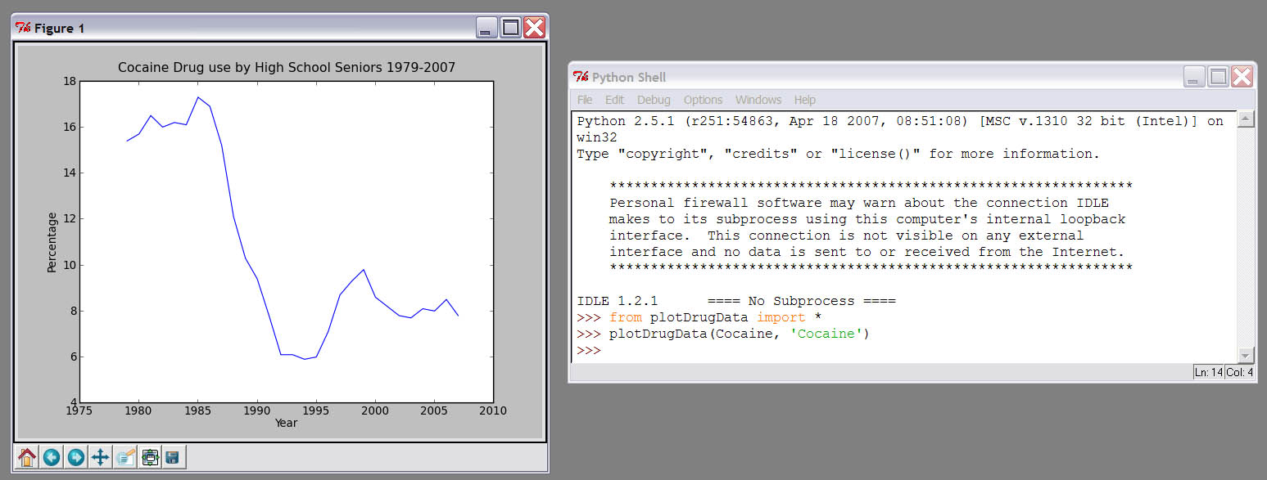

As you can see, accessing the command you defined is done in the same way that you access the commands in the Pylab interface. This is one of the nice features of Python, which encourages its users to extend the capabilities of the system through defining new functions and storing them in modules. Thus, importing functionality from a module you write is not different from importing commands from a module someone else has written (such as Pylab). In general the Python import command specifies two features: the module name and what is being imported:

from <MODULE NAME> import <SOMETHING>

where <MODULE NAME> is the name of the module (e.g., pylab, plotDrugData) and <SOMETHING> specifies the commands or capabilities that you are importing. By specifying * for <SOMETHING> we tell Python to import everything defined in the module. So, the command from pylab import * tells Python to import everything defined in the pylab module. Everything defined in the module is listed and documented on the Matplotlib website (http://matplotlib.sourceforge.net/backends.html; Pylab is the interface that allows you to easily use the computational power of Matplotlib, an extensive math and plotting library).

Do This: Play around with the plotDrugData command for a while. Use it to plot different types of data. Modify the module so that the plot line is red. Save your changes.

ALERT IDLE BUG: When you modify a module, you need to let IDLE know that the function has changed. So, you may think that all you need to do is re-import the module. Go ahead, try it. Use the plotDrugData to plot the Cocaine data again. Is the line red? No it is not. That is because IDLE notices that the plotDrugData module information is already loaded and does not over-write the old information with the new. To get IDLE To recognize your changes, you must unfortunately exit out of IDLE and then reload IDLE. This is, in part, because of the way we have to load IDLE for the Pylab interface to work.

Returning a Value

Parameters provide a way for you (or the user) to give a command information it needs to perform its task. These parameters are the input to the function. Sometimes, however, we also require a function to return some information, i.e., provide output! This task involves some concepts we will be addressing in more detail in the next chapter, but the actual task of returning a value is actually quite simple.

A common situation in which you might require a program or function to return a value is the performance of a simple calculation. Consider for example, the function mean(<DATA>) which returns the average of the data stored in some variable, indicated by <DATA>. Variables will be discussed in more detail in the next chapter. Executing the following in IDLE, for example:

>>> mean(AnyDrug)

will produce the following:

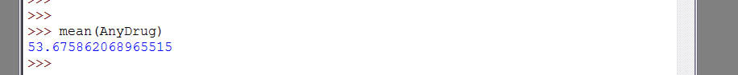

In other words, executing the command produces an output. In the above example, that output is displayed on the screen. We can also tell Python to store the value that is generated by assigning it to a variable through the use of the following syntax

>>> x = mean(AnyDrug)

When defining our own commands, we can let Python know that we for the function to output a result by using the command return. For example, perhaps we get confused by the term “mean”:

def average(x):
# returns the mean of the data, x
return mean(x)

or alternatively

def average(x):
# returns the mean of the data, x
a = mean(x)
return a

The general form of the return statement is

return <EXPRESSION>

That is, the function in which this statement occurs will return the value of the expression (and incidentally exit the function) when it encounters the return statement. Thus, the function will exit as soon as the return statement is evaluated. For example:

def average(x):
# returns the mean of the data, x
a = mean(x)
return a
plot(x)

In the above function, the final command (plot(x)) will not get executed! In fact, if you enter this function interactively in IDLE or in the IDLE editor, it will stop indenting, indicating that the function definition has ended.

Functions as Building Blocks

Now that we have learned to define new commands from existing ones, we can start to discuss a little bit more of about how Python works. The basic syntax for defining a function in Python is:

def <FUNCTION NAME> (<PARAMETERS>):
<SOMETHING>
:
<SOMETHING>

In other words, to define a new function we start by using the word def, followed by the name of the function (<FUNCTION NAME>). This is then followed by any <PARAMETERS> enclosed in parentheses, followed by a colon (:). This line is followed by the commands that make up the function definition. Each command needs to be place on a separate line and should be indented the same amount. The number of spaces that makes up the indentation is not important as long as all the lines are aligned. This serves two purposes. First, it makes the definition more readable. For example, consider the following:

def plotDrugData():
plot(Year, Marijuana)
show()
xlabel('Year')
ylabel('Percentage')
title('Marijuana Drug use by High School Seniors 1979-2007')

def plotDrugData():
plot(Year, Marijuana); show()
xlabel('Year'); ylabel('Percentage')
title('Marijuana Drug use by High School Seniors 1979-2007')

The first definition will not be accepted by Python:

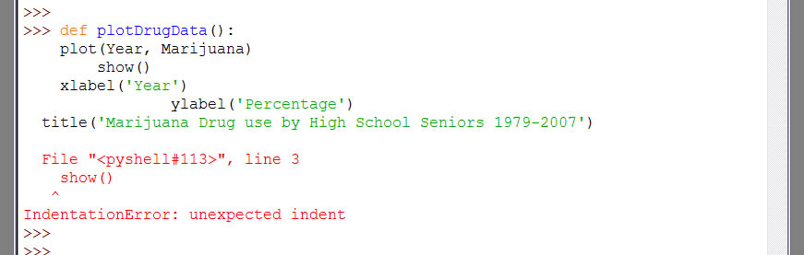

IDLE reports that there is an IndentationError (a type of syntax error) and either highlights or reports the line number on which the error occurred. This is because Python strictly enforces the indentation rule described above. The second definition, however, is acceptable, for two reasons: 1) indentation is consistent and commands can be entered on the same line if they are separated by a semi-colon (;). We would recommend that you continue to enter each command on a separate line until you are more comfortable with Python. Plus, it makes code a lot easier to read. Most importantly, however, you will notice that IDLE makes indentation easy by usually doing it for you!!

Another feature of IDLE that enhances readability of Python programs is the use of color to highlight certain types of syntax. In the screen shot above, for example, the word def is in orange, the name of the function is in blue, strings are in green, and the error message is in red. Other colors are used in other situations.

The idea of code re-usability that is introduced through the use of functions is a very power and important concept in computing. When we define a new command using existing commands we abstract a new set of instructions for the computer to perform. We can also define other functions that use functions we have already defined (such as plotDrugData). Thus, functions are the basic building-blocks of the bigger structure that is a complex program.

Python Review
In this exercise we learned several Python commands. These included:

- Importing Modules:

from <MODULE NAME> import <SOMETHING>

- String Concatenation:

A phrase in between two single quotes (e.g., 'Any Drug') is a special piece of code called a string. We will be talking about more strings later, but in this chapter we did a bit of string manipulation that needs to be addressed. In the plotDrugData module we included the following instruction:

title(name + ' Drug use by High School Seniors 1979-2007')

which told Python to set the text title to the string provided in the parameter, name, added to the start of ' Drug use by High School Seniors 1979-2007'. Try it out by entering and concatenating strings in IDLE.

- Function Definitions:

def <FUNCTION NAME>(<PARAMTER>):
<SOMETHING>
:
<SOMETHING>

- Return Statements

return <EXPRESSION>

- Multiple commands can be entered on the same line if separated by a semi-colon (;)

- Arrays:

Arrays are lists of values stored as a single variable, using the syntax [value1, value2, value3, ...]

Pylab Review
In this exercise we learned several Pylab commands. These included those for putting simple labels on plots:
- Label Axes:

xlabel('label for x axis')
ylabel('label for y axis')
zlabel('label for z axis')

- Label Title:

title('plot title')

where the phase in between the single quotes is a string that indicates the text to be printed. Like lines, labels have properties that can be modified using keywords. These include the following:

- color: a matplot lib color argument
- fontsize: a scalar value
- fontweight: 'bold', 'normal', 'light'
- fontangle: 'normal', 'italic', 'oblique'
- font: 'Courier', 'Times', 'Sans', 'Helvetica'
- horizontalalignment: 'left', 'right', 'center'
- verticalalignment: 'bottom', 'center', 'top'

for example

>>> xlabel('Year', color = 'r', fontweight ='bold')

Adds the a red, bold label Year to the x-axis.

- Calculating an Average:

The function mean(<ARRAY OF DATA>) can be used to calculate the average for a list of numeric data values.

Exercises
- Read Chapters 2 and 3 from the Tufte book. Pick a figure in Chapter 2 that Tufte argues is distorted but does not provide a correction. Why is this figure distorted? How should the distortion be corrected? Sketch a diagram or use EXCEL to generate a figure that corrects the problem. In Chapter 3, Tufte asks why artists draw graphics that lie. Considering that most scientists are not artists, in addition to the reasons listed in the Chapter, why else would a scientific “artist” produce a graphic that lies? Are any of these reasons justified (ethically)?

- Define and save as a module a function that generates a series of bar charts on a single figure for the following drugs: Alcohol, Cigarettes, Marijuana, and Cocaine (the order is important to be able to visualize all the data). You can set a color for each bar graph using the keyword argument color (e.g., color = 'k'). The function should also label the axes and title the graph. Run you function in IDLE and save the result. What does this visualization tell you about the relationship among the use of these drugs over time? Is this a good visualization? Why or why not?

- Define and save as a module a function that plots one type of drug data versus another (e.g., Marijuana versus Cocaine use). The function should have parameters that allow you to specify the two drugs to be compared and the format of the line (e.g., solid red line 'r', dashed blue line '--b', magenta squares 'ms'). The function should also label the axes and title the graph. Use your function to generate a variety of comparisons; save your two favorites and explain the relationship illustrated by each visualization.

- Define and save as a module a function that calculates the average drug use from 1979 to 2007 for each type of drug (except AnyDrug). You can return the calculated values by creating a type of variable called an array that stores all of the results using the following syntax:

averageUse = [aMarijuana, aHallucinogens, aCocaine, etc...]

and then returning the averageUse variable. Test your function in IDLE.

- Define and save as a module a function that calculates the average drug use for each type of drug (except AnyDrug) and then plots the average drug use for each type of drug as a scatter plot using the plot command (which can generate univariate as well as bivariate graphs). HINT: you already did part of this!!! Labeling the ticks on the x-axis correctly is actually quite a difficult task and we will leave it for another day. When you print out your final plot, you can label the ticks with a pencil so that it is easier to interpret the plot. The function should also label the axes and title the graph. Save and run the module; save the resulting plot and explain the illustrated relationship. What insight does this visualization give you into the relative use of each drug by high-school seniors over the past 28 years? Is this a good visualization? Why or why not?

NOTE: New Python and Pylab commands will frequently be introduced throughout the text. All new commands will be summarized at the end of the chapter in which they are introduced (Python or Pylab Review sections)

